**Kaprekar’s Constant:**

**write a problem statement for finding and codinf for it kaprekar's constant**

Problem Statement: Finding Kaprekar's Constant

You are tasked with writing a Python program to find Kaprekar's constant, also known as 6174, using Kaprekar's process. Kaprekar's constant is a special number that exhibits an interesting property when a specific process is applied to it.

Your program should take a four-digit number as input and apply Kaprekar's process iteratively until it converges to Kaprekar's constant. The process involves rearranging the digits of the number to form the largest and smallest numbers possible, subtracting the smaller number from the larger number, and repeating this process with the result until Kaprekar's constant is reached. The program should output the sequence of numbers generated during this process until convergence.

Input:

* A four-digit integer within the range of 1000 to 9999 (inclusive).

Output:

* The sequence of numbers generated by applying Kaprekar's process until Kaprekar's constant (6174) is reached.
* If the input is not a valid four-digit number, the program should output an error message indicating invalid input.

Note:

Ensure that your program handles edge cases such as:

* Input validation for non-four-digit numbers.
* Handling cases where the input number is already Kaprekar's constant.
* Proper handling of the Kaprekar process to avoid infinite loops.

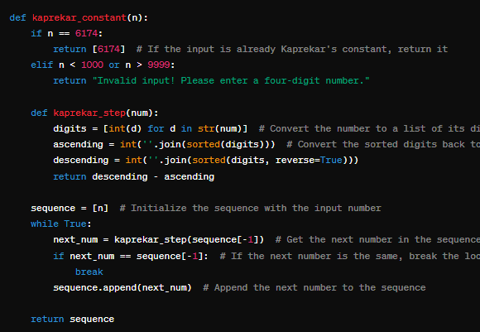

**write 5 test cases for it**

**Chatgpt:**

Here are five test cases to validate the Kaprekar's constant finding program:

Valid Input - Converging to 6174:

Input: 3524

Expected Output: Kaprekar's sequence for 3524: [3524, 3087, 8352, 6174]

Valid Input - Converging to Kaprekar's Constant Directly:

Input: 6174

Expected Output: Kaprekar's sequence for 6174: [6174]

Invalid Input - Less Than Four Digits:

Input: 123

Expected Output: Invalid input! Please enter a four-digit number.

Invalid Input - Greater Than Four Digits:

Input: 12345

Expected Output: Invalid input! Please enter a four-digit number.

Valid Input - Different Starting Number:

Input: 7401

Expected Output: Kaprekar's sequence for 7401: [7401, 4104, 4320, 6174]

These test cases cover scenarios such as valid inputs that converge to Kaprekar's constant, an input that is already Kaprekar's constant, invalid inputs (less than four digits or greater than four digits), and a test case with a different starting number to ensure the program works correctly with various inputs.

**is there any way to optimize the orginal code**

**Chatgpt:**

Yes, the original code can be optimized in a few ways to improve performance and readability. Here are some optimizations:

Check for Kaprekar's Constant as an Exception:

* Instead of checking if the input number is already Kaprekar's constant inside the loop, you can check this condition initially and return early if it's already 6174. This can save unnecessary iterations.

Use a Generator Function:

* Instead of storing the entire sequence in a list, you can use a generator function to yield each number in the sequence as needed. This can save memory, especially for large sequences.

Avoid Recalculating Sorted Digits:

* You can calculate the sorted digits of the number once and reuse them in each iteration of Kaprekar's process, instead of recalculating them multiple times.

Here's an optimized version of the code incorporating these optimizations:

